Stats Video Lecture – Probability Examples

Week 2, Video 3

1. World Values Survey
   1. survey that polls people worldwide on work, life, family politics
   2. of the 77882 respondents, 36.2% agree that “Men should have more rights to a job than women.”
   3. Of the 77882 respondents, 13.8% have a university degree or higher and 3.6% fall into both categories
   4. P(Agree) = 0.362
   5. P(Degree) = 0.138
   6. P(Both) = 0.036
   7. Are the population that agree with the statement and the population that has a university degree disjoint? No, P(A and B) does not equal zero
   8. Show in a Venn Diagram

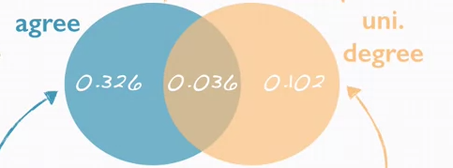

* 1. What is the P that a random person has a degree OR agrees with the statement
     1. P(A or B) = P(A) + P(U) – P(A and U) = 0.362 + 0.138 – 0.036= 46.4%
  2. what P of the population do not have a degree and disagree with the statement?
     1. P(neither agree nor uni degree) = 1 – P(A or U) = 1 – 0.464 = 53.6%
  3. Is the event that someone agrees with the statement independent that they have a degree?
     1. Use Product Rule: if A and U are indep, then P(A and U) = P(A) * P(U)
        1. P(A) * P(U) = 0.0499
        2. P(A and U) = 0.036
     2. No
  4. What is the prob that at least 1 in 5 randomly selected people agree with the statement?
     1. P(Agree) = 0.362
     2. P(Disagree) = 1 – 0.362 = .0.638
     3. P(at least1 agrees) = 1 – P(none agree)
     4. =1 – P(DDDDD)
     5. =1 - 0.638^5 = 0.89429308615
     6. **Generally, the probability of at least one is the same as 1 –P(none)**